Level-6

Final Project

“Student Notice Board”

By

Ankush Sehgal

Table of Contents

Project Proposal 3

Goals and Objectives 3

Project Scope 3

Project Deliverables 3

Project Specifications 3

Target Audience 4

Project Tasks and Milestones 4

Resource Requirements 5

Project Assumptions 5

Project Report 5

Detail Design 6

Home Page 6

Admin Registration Page 6

Login Page 7

Notices Page admin 7

Admin Students Page 8

Admin Notice View Page 8

Student Notices Page 8

New Student Registration Page 9

Project Testing 10

System Usability Testing 10

Testing 10

User Manual 12

System Overview 12

System Summary 12

System Configuration 12

User Access Levels 12

# Project Proposal

## Goals and Objectives

The student notice board is an online web application implemented using ASP.Net. The main goal of this application is to provide information about various announcements and special events to the registered students. In this application there are admin and student accounts. Admin has the right to register a new admin for the application. Admin can add new notice, view, edit, and delete the existing ones. Admin can also edit, delete, and access details of various students registered with the application. Admin can also delete and access details of the notice views. Moreover, students can only view notices available at the application. New students can sign-up for the application for free.

## Project Scope

This is a 20 days project in which I have implemented an online web application named “Student Notice Board”. The scope of this project is to help students to find useful notices at the time.

## Project Deliverables

The following table states the deliverables for the project:

|  |  |
| --- | --- |
| **Deliverable** | **Description** |
| Final Report | Introduces the plan and elaborates on the specifications and criteria, as well as presents the goal, timeline, code, and other important details. |
| Coding | This will be the project's executable code. |
| Documentation | This will demonstrate how the web application can be used. |
| Testing | This will provide the project's test details |

## Project Specifications

* Add, view, delete, and edit notices.
* Admin can edit, delete, and access details of students.
* Admin can delete and access details of notice views.
* Students can view notices.
* New students can sign-up for the application.

## Target Audience

Students who are willing to keep themselves up to date what is going around them will be the target audience for this application. The age can be 7 plus to 20 or more.

## Project Tasks and Milestones

Here are the tasks and milestones of the project:

|  |  |  |  |  |  |  |  |  |  |  |  |  |  |  |  |
| --- | --- | --- | --- | --- | --- | --- | --- | --- | --- | --- | --- | --- | --- | --- | --- |
| **Stages** | **Activities** | **Week1-2** | | | | **Week-2-3** | | | | | **Week-3-4** | | | | |
| Planning | **Technological analysis and brainstorming** |  |  |  |  |  |  |  |  |  |  |  |  |  |  |
| **Initial Meeting** |  |  |  |  |  |  |  |  |  |  |  |  |  |  |
| **Project Proposal** |  |  |  |  |  |  |  |  |  |  |  |  |  |  |
| Implementation | **Database Design** |  |  |  |  |  |  |  |  |  |  |  |  |  |  |
| **UI Design** |  |  |  |  |  |  |  |  |  |  |  |  |  |  |
| **Identity Framework Implementation** |  |  |  |  |  |  |  |  |  |  |  |  |  |  |
| **UI Implementation** |  |  |  |  |  |  |  |  |  |  |  |  |  |  |
| **Admin Interface Implementation** |  |  |  |  |  |  |  |  |  |  |  |  |  |  |
| **User interface Implementation** |  |  |  |  |  |  |  |  |  |  |  |  |  |  |
| **Testing** |  |  |  |  |  |  |  |  |  |  |  |  |  |  |
| Closing | **Final Documentation** |  |  |  |  |  |  |  |  |  |  |  |  |  |  |

## Resource Requirements

Following technologies and development method:

* Asp.net MVC Framework
* Microsoft word for documentation.
* Identity framework- ASP
* Windows Operating System
* 64-bit processor and 8 GB or more RAM

## Project Assumptions

* One student and one admin will be registered by default.
* The application will be open source.

# Project Report

#### Functional Requirements

The functional requirements of this project are divided into types. One for Admin, and one for a student.

|  |  |
| --- | --- |
| **Users** | **Functional Requirements** |
| **Admin** | * Add new notice, view, edit and delete the existing ones * Admin can edit, delete, and access details of students. * Admin can delete and access details of the notice view. |
| **Student** | * Students can view the available notices. * New students can sign-up for free. |

#### Non-Functional Requirements

|  |  |
| --- | --- |
| **Operational** | * The app should be able to run on all browsers and devices. |
| **Performance** | * Aiming to have a 99% performance uptime. |
| **Security** | * Only Admin has full access to the system. |

## Detail Design

### Home Page

This is the main landing page of the application. This page contains 5 main navigation buttons – Home, Notices, Student Registration, Login, and Register Notice Admin. 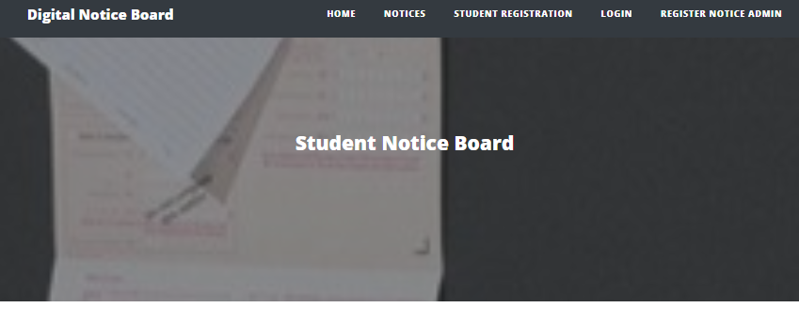

### Admin Registration Page

An Admin can register another admin by using the register page.

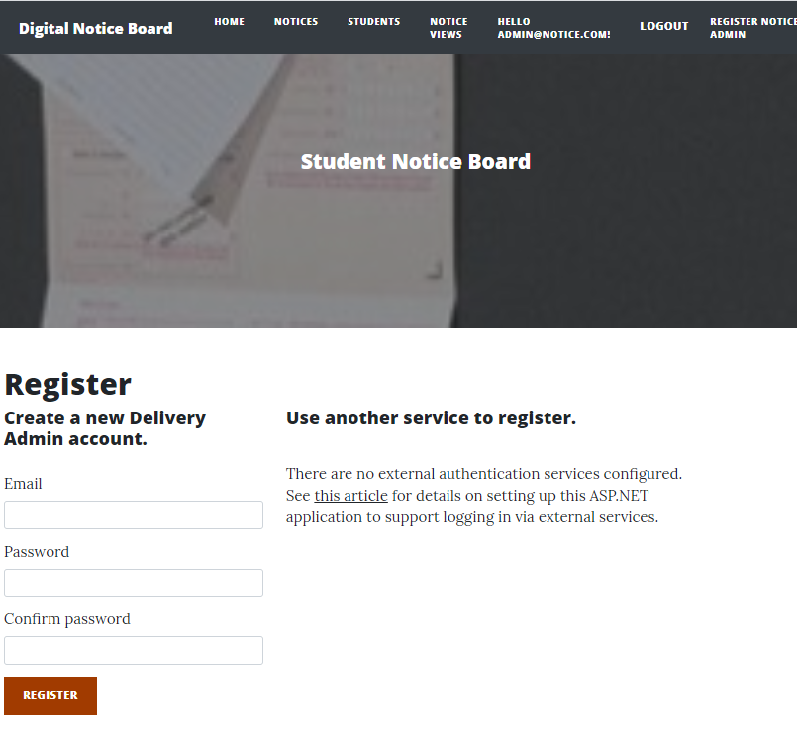

### Login Page

With the help of this page, admin and students can login to the application by using their credentials.

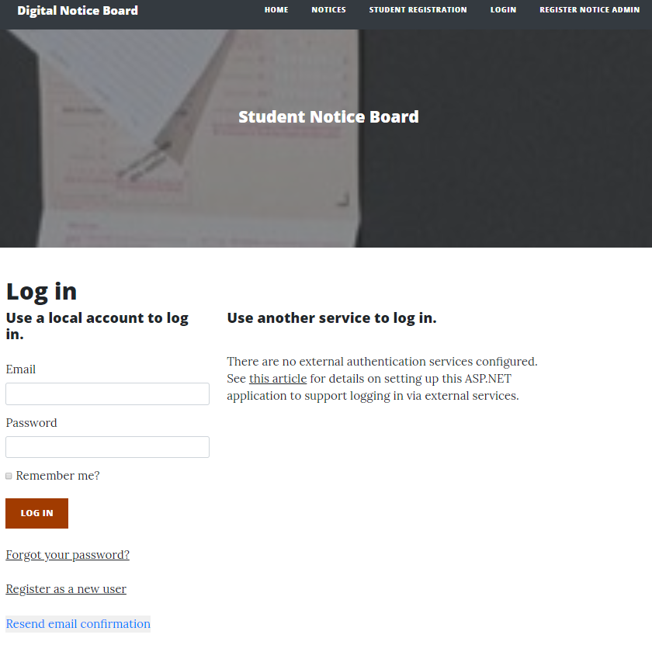

### Notices Page admin

With the help of this page, admin can add new notices, edit, delete, and view the details existing ones.

### Admin Students Page

With the help of this page, admin can edit, delete, and view details of the students.

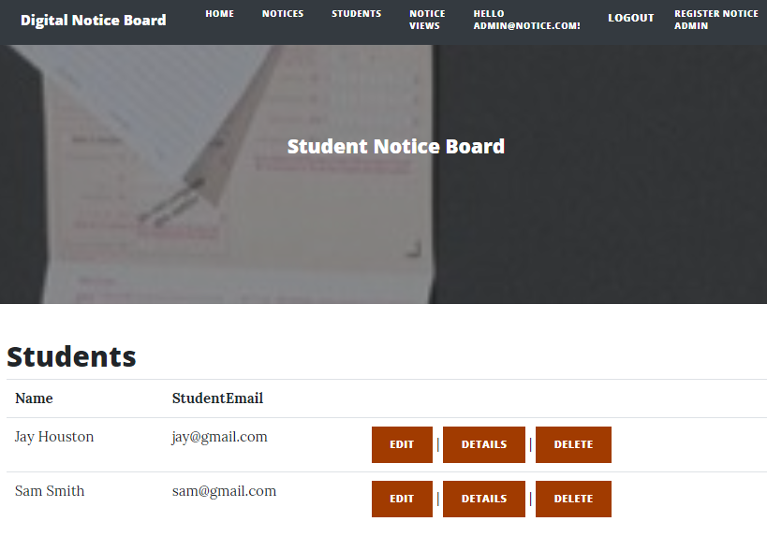

### Admin Notice View Page

This page will show the rights of admin on Notice views. An admin can delete and see the details of the notices.

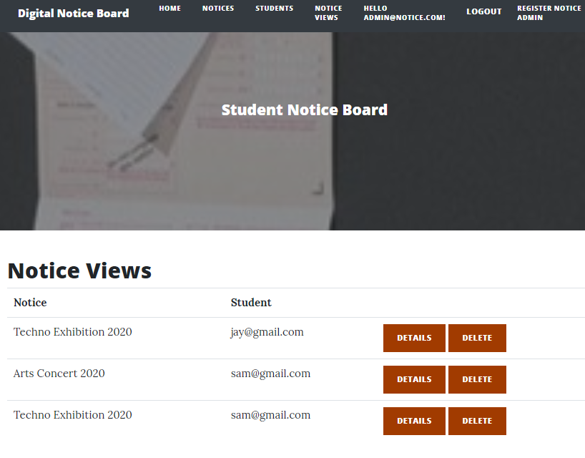

### Student Notices Page

With the help of this page, registered students can view the available notices.

### New Student Registration Page

With the help of this page new students can register with the application.

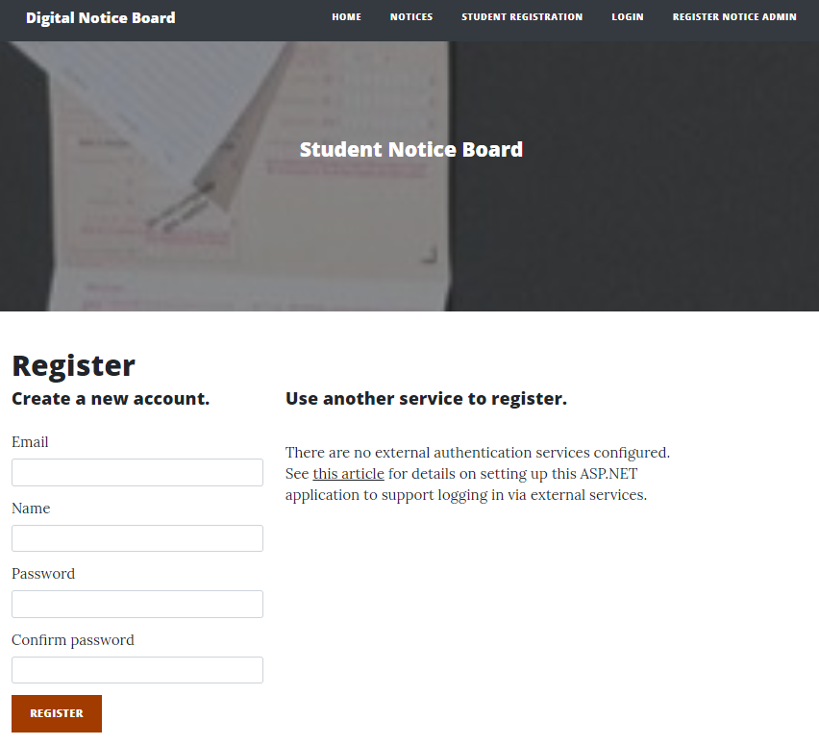

# Project Testing

## System Usability Testing

### Testing

**Tester 1**

|  |  |  |  |  |  |
| --- | --- | --- | --- | --- | --- |
| **Tester – 1** | | **Scale** | | | |
| **No.** | **Question** | **Strongly Agree** | **Agree** | **Neutral** | **Disagree** |
| 1 | I think that I would like to use this application more frequently |  |  |  |  |
| 2 | I found the system complicated |  |  |  |  |
| 3 | Is the system easy to use? |  |  |  |  |
| 4 | Do you think you need the support of a technical person to use this system? |  |  |  |  |
| 5 | All functions of the system were well-integrated |  |  |  |  |
| 6 | Did you find any inconsistencies in this system |  |  |  |  |
| 7 | I think most people would learn to use this system very quickly |  |  |  |  |
| 8 | I found the system very challenging to use |  |  |  |  |
| 9 | I felt very confident using the system |  |  |  |  |
| 10 | I needed to learn a lot of things before using the system |  |  |  |  |

**Tester 2**

|  |  |  |  |  |  |
| --- | --- | --- | --- | --- | --- |
| **Tester -2** | | **Scale** | | | |
| **No.** | **Question** | **Strongly Agree** | **Agree** | **Neutral** | **Disagree** |
| 1 | I think that I would like to use this application more frequently |  |  |  |  |
| 2 | I found the system complicated |  |  |  |  |
| 3 | Is the system easy to use? |  |  |  |  |
| 4 | Do you think you need the support of a technical person to use this system? |  |  |  |  |
| 5 | All functions of the system were well integrated |  |  |  |  |
| 6 | Did you find any inconsistencies in this system |  |  |  |  |
| 7 | I think most people would learn to use this system very quickly |  |  |  |  |
| 8 | I found the system very challenging to use |  |  |  |  |
| 9 | I felt very confident using the system |  |  |  |  |
| 10 | I needed to learn a lot of things before using the system |  |  |  |  |

# User Manual

### System Overview

The student notice board is an online web application implemented using ASP.Net. The main goal of this application is to provide information about various announcements and special events to the registered students. In this application there are admin and student accounts. Admin has the right to register a new admin for the application. Admin can add new notice, view, edit, and delete the existing ones. Admin can also edit, delete, and access details of various students registered with the application. Admin can also delete and access details of the notice views. Moreover, students can only view notices available at the application. New students can sign-up for the application for free.

## System Summary

### System Configuration

Student Notice Board is a web application developed using Asp.net MVC Framework. It works on most modern web browsers and does not need a special program setup. Internet access is required as a web application.

### User Access Levels

Only registered customers can access the features of the Student Notice board web application.

**Admin:** Full access to the notices, students, and notice views.

**Students:** Limited access can only see the available notices.